Design Thinking Project Workbook

#### Don't find customers for your product but find products for your customers

1. **Team**

**Team Name:** Echo Bots

## Team Members:

Vamsi, TeamLead, 2320030035

Hemanth,Team Member, 2320030150

M.Venkat Satish, Team Member, 2320090082

# Problem/Opportunity Domain

## Domain of Interest:

The domain of interest for this project is Customer Support Automation. Specifically, it focuses on automating the process of responding to common customer inquiries through email using advanced NLP techniques and machine learning models.

## Description of the Domain:

Customer support plays a critical role in the success of any business, particularly in industries where timely responses and accurate solutions are essential. However, handling repetitive and routine inquiries manually can be time-consuming and resource-intensive. Common challenges include high response times, inconsistent customer experiences, and the significant workload on support teams. Automating email responses offers a key opportunity to streamline these operations, reduce costs, and improve customer satisfaction. By leveraging machine learning and NLP, businesses can respond quickly and accurately to frequently asked questions, while allowing human agents to focus on more complex issues.

## Why did you choose this domain?

This domain was chosen due to the increasing demand for automation in customer service, as businesses seek to enhance efficiency and reduce operational costs. There is a strategic market potential in developing automated systems that handle routine customer inquiries, which can significantly improve response times and overall customer satisfaction. Additionally, the application of Natural Language Processing and AI in this domain aligns with the team's passion for cutting-edge technologies, as well as solving real-world problems by relieving pressure on human customer service agents.

# Problem/Opportunity Statement

## Problem Statement:

Customer support teams face an overwhelming number of repetitive inquiries, leading to slow response times, decreased customer satisfaction, high operational costs, and inefficient use of resources. Automating responses to routine questions can significantly enhance support efficiency and improve overall customer experience, while allowing human agents to focus on complex inquiries.

## Problem Description:

Businesses frequently receive large volumes of emails with similar questions regarding products, services, shipping information, account details, and more. Manually addressing each of these inquiries is time- consuming, error-prone, and inefficient. This leads to long response times, customer frustration, and increased pressure on support teams. The issue becomes more pronounced during peak seasons or events, such as product launches or sales promotions, where inquiry volume dramatically increases, often exceeding the capacity of the support team.

## Context (When does the problem occur):

The problem occurs most notably during times of high customer activity, such as holiday seasons, special promotions, and product releases. Additionally, businesses with large customer bases or highly sought-after products face constant email inquiries. The inability to respond quickly in these critical periods can result in missed opportunities, lost revenue, and damaged customer relationships.

## Alternatives (What does the customer do to fix the problem):

* **Manual Responses:** Businesses assign more staff or reassign internal resources to handle the volume, but this solution increases labor costs and leads to burnout.
* **FAQ Pages:** Companies provide static FAQ pages, but they lack personalization and often fail to address specific customer needs.
* **Auto-reply Templates:** Predefined email templates are used, but these responses are generic and don’t always resolve the customer's inquiry, leading to further frustration.
* **Basic Chatbots:** Some companies implement basic chatbots to manage inquiries, though these often lack the sophistication to handle more complex requests or personalized situations.

## Customers (Who has the problem most often):

This problem is most commonly encountered by businesses with high customer interaction, such as e- commerce companies, tech service providers, and telecommunication firms. Small to mid-sized enterprises are particularly vulnerable, as they may lack the resources to scale their support teams efficiently.

## Emotional Impact (How does the customer feel):

Customers often feel frustrated, annoyed, and dissatisfied when their inquiries are not answered promptly or adequately. The lack of a timely response makes customers feel undervalued and overlooked, which can erode trust and loyalty to the brand.

## Quantifiable Impact (What is the measurable impact):

* **Response Times:** Average response times can increase from a few hours to several days during peak periods, significantly affecting customer satisfaction.
* **Operational Costs:** Increased labor costs due to the need for more customer service representatives, along with possible overtime payments.
* **Customer Churn:** Longer response times and unresolved inquiries can lead to a loss of customers, negatively affecting revenue.
* **Lost Sales:** Missed opportunities for upselling or resolving issues that could convert inquiries into sales.
* **Reduced Efficiency:** Human agents spending excessive time on repetitive inquiries can lower productivity and job satisfaction.

## Alternative Shortcomings (What are the disadvantages of the alternatives):

* **Manual Responses:** Time-consuming, costly, and inefficient for handling repetitive tasks. High burnout rates among customer support staff.
* **FAQ Pages:** Lack of personalization, often leading to more inquiries if customers don’t find the exact answer.
* **Auto-reply Templates:** Generic responses fail to address specific concerns and may require follow- up, further delaying resolution.
* **Basic Chatbots:** These often struggle with understanding context and providing accurate responses, especially for more nuanced inquiries, and can frustrate users if they are unable to escalate issues to a human representative.

## Any Video or Images to showcase the problem:

No specific videos or images are available at this time. However, visual data such as workflow charts, email volume trends, and customer satisfaction survey results could be used to illustrate the problem and its impact more effectively during presentations or in reports.

# Addressing SDGs

## Relevant Sustainable Development Goals (SDGs):

The following SDGs are directly impacted by the problem or opportunity of developing an automated email response chatbot for customer service:

* SDG 8: Decent Work and Economic Growth
* SDG 9: Industry, Innovation, and Infrastructure
* SDG 12: Responsible Consumption and Production

## How does your problem/opportunity address these SDGs?

#### SDG 8: Decent Work and Economic Growth

By automating routine customer inquiries, businesses can improve operational efficiency and reduce the workload on customer service teams. This allows human agents to focus on more complex tasks that contribute to personal development and job satisfaction, promoting decent work environments. Automation also helps companies scale their operations, contributing to economic growth by enabling businesses to handle increased volumes of inquiries without proportionally increasing costs or employee burnout.

#### SDG 9: Industry, Innovation, and Infrastructure

The development of an AI-powered chatbot for email automation promotes technological innovation within the customer service industry. This project leverages machine learning and Natural Language Processing (NLP) technologies, contributing to the modernization of industry infrastructure and enhancing business resilience in the digital age. It showcases how businesses can use advanced technologies to create more intelligent and efficient communication systems, laying the groundwork for further innovations.

#### SDG 12: Responsible Consumption and Production

Automating customer support inquiries leads to the more efficient use of resources, both human and technological. By reducing the need for excessive human intervention in repetitive tasks, businesses can optimize their operations and minimize waste in terms of time, labor, and energy. Additionally, automated systems can contribute to sustainable business practices by reducing the carbon footprint associated with traditional customer support models that require large-scale staffing and infrastructure.

# 5. Stakeholders

### Who are the key stakeholders involved in or affected by this project?

* + **School Management**: They benefit from using the chatbot for handling school-related inquiries efficiently.
  + **College Management**: They are stakeholders due to their need for an automated system to respond to inquiries from students, faculty, and staff.
  + **Software Company**: The company responsible for developing and deploying the chatbot, ensuring it runs effectively and is scalable.
  + **Chemical Company**: They may use the chatbot for automating inquiries related to product details, safety guidelines, or customer support.

### What roles do the stakeholders play in the success of the innovation?

* + **School Management**: They play a critical role as end-users, providing feedback and ensuring the system aligns with their operational needs.
  + **College Management**: Similar to school management, they will ensure the system is tailored to academic inquiries and offer feedback to improve chatbot effectiveness.
  + **Software Company**: As the main developers, they are pivotal in ensuring the innovation is successfully implemented, meets technical standards, and performs optimally.
  + **Chemical Company**: They will likely provide domain-specific requirements for the chatbot's responses, ensuring it understands and handles technical queries efficiently.

### What are the main interests and concerns of each stakeholder?

* + **School Management**: Interested in automating inquiries to save time and reduce workload. Their concern is whether the chatbot will handle a variety of school-related inquiries accurately.
  + **College Management**: Their interest lies in reducing manual responses to frequent inquiries, allowing staff to focus on more critical tasks. A concern may be the accuracy and relevance of responses to complex academic queries.
  + **Software Company**: Interested in creating a reliable and scalable product. Their concern is ensuring the chatbot meets deadlines and performs efficiently under different conditions.
  + **Chemical Company**: They are interested in automating customer support and providing immediate, accurate information on their products. Their concern might be whether the chatbot can handle technical jargon effectively.

### How much influence does each stakeholder have on the outcome of the project?

* + **School Management**: Medium to high influence, as they provide input on the specific features and requirements for school-related inquiries.
  + **College Management**: Medium influence, with their feedback being crucial in tailoring the chatbot for academic environments.
  + **Software Company**: High influence, as they develop and maintain the chatbot, directly affecting its performance and capabilities.
  + **Chemical Company**: Medium influence, especially if their requirements involve highly technical or domain-specific features that impact the chatbot's development.

### What is the level of engagement or support expected from each stakeholder?

* + **School Management**: High engagement, especially during the requirements-gathering phase, as they provide input on the kinds of inquiries the chatbot should handle.
  + **College Management**: Moderate to high engagement, as they will be actively involved in testing and providing feedback.
  + **Software Company**: Full engagement, as they will be responsible for the development, deployment, and maintenance of the chatbot.
  + **Chemical Company**: Moderate engagement, providing essential information on technical queries and customer support automation needs.

#### Are there any conflicts of interest between stakeholders? If so, how can they be addressed?

* + **Potential Conflicts**:
    - **School and College Management** may have slightly different requirements for how inquiries are handled, leading to potential conflicts in prioritizing development tasks.
    - **Software Company** may be focused on keeping costs down or meeting deadlines, which might conflict with the detailed, domain-specific requests from other stakeholders (e.g., the Chemical Company).
  + **Mitigation**: Regular meetings to prioritize requirements, open communication about trade-offs, and involving all stakeholders in key decisions.

#### How will you communicate and collaborate with stakeholders throughout the project?

* + **Regular Meetings**: Weekly or bi-weekly check-ins with school and college management to gather feedback.
  + **Workshops**: For the software and chemical companies, holding domain-specific workshops to ensure the chatbot handles technical queries correctly.
  + **Emails and Reports**: Sending regular progress reports to all stakeholders to keep them informed about developments and milestones.

#### What potential risks do stakeholders bring to the project, and how can these be mitigated?

* + **School and College Management**: Risk of changing requirements mid-project. Mitigation: Keep requirements flexible but clearly defined early on.
  + **Software Company**: Risk of not meeting deadlines or delivering a product that doesn't match stakeholder needs. Mitigation: Regular updates and milestones to ensure alignment.
  + **Chemical Company**: Risk of the chatbot failing to handle technical queries effectively. Mitigation: Incorporate domain experts early in the development process and test the chatbot with real-world scenarios.

# 6. Power Interest Matrix of Stakeholders

#### Power Interest Matrix:

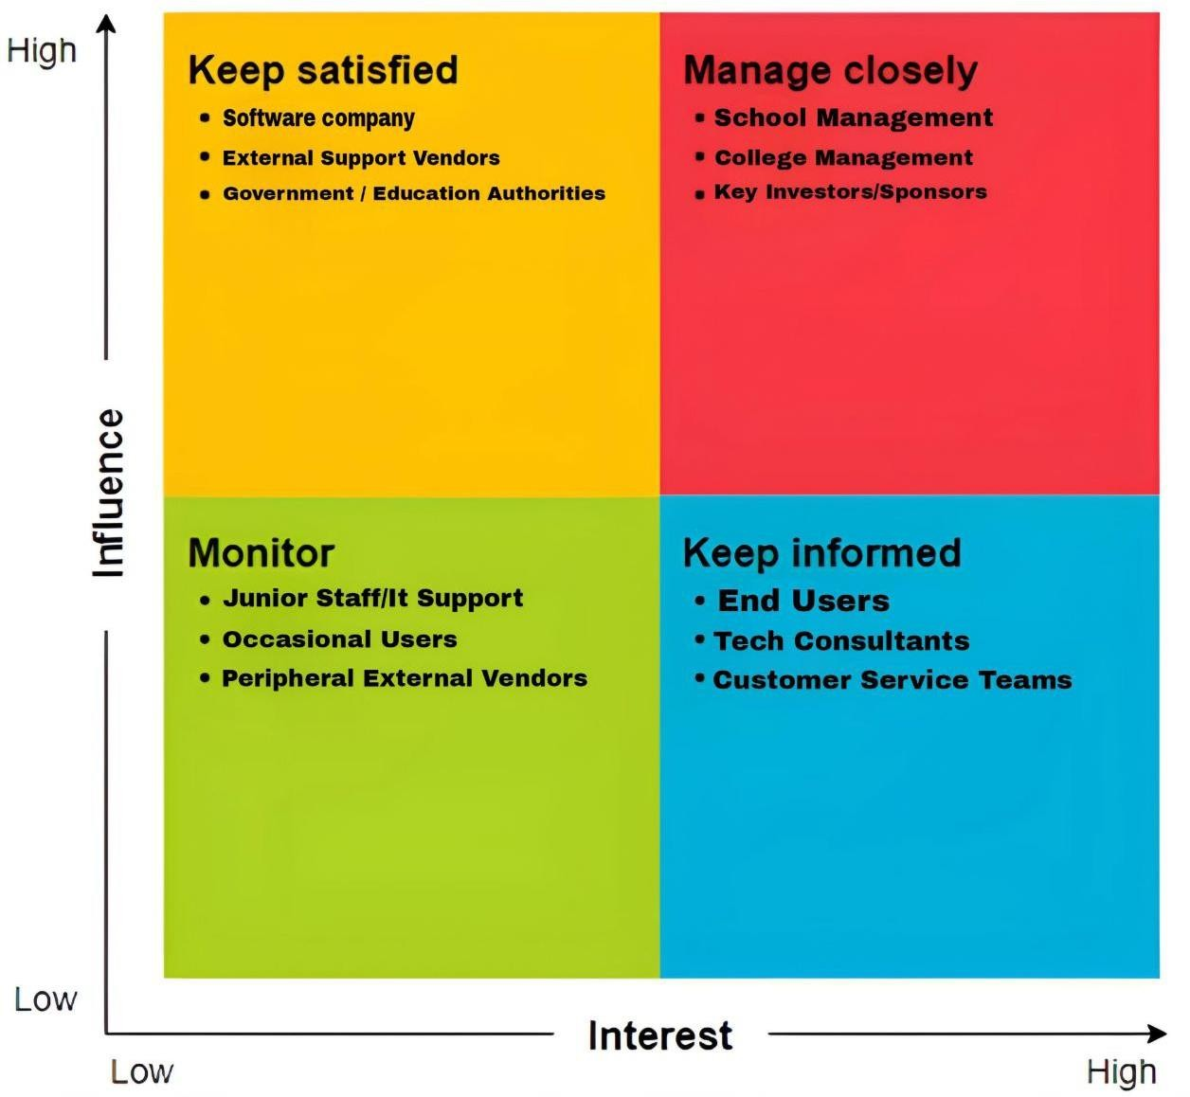

**High Power, High Interest**:

* + **School Management**: They have a significant influence on the success of the project as they are key end-users and will directly benefit from the chatbot.
  + **College Management**: Like school management, they hold high influence and interest, as the chatbot must meet their specific needs for automated responses in an academic environment.

#### High Power, Low Interest:

* + **Software Company**: They hold high power because they are responsible for developing and implementing the chatbot. However, their interest may be more focused on technical execution and delivery rather than everyday usage, depending on the scale of the project.

#### Low Power, High Interest:

* + **Chemical Company**: Although their direct influence on the overall project may be lower, they have high interest in ensuring the chatbot is capable of handling specific inquiries, especially those related to their product information and technical support.

#### Low Power, Low Interest:

* + **Other General Users/Clients**: This could include customers or lower-level staff who interact with the chatbot occasionally but have less impact on its design or development and less direct interest in its implementation.